**[22] Design DFA Which Accepts String With Odd Number Input ‘A’**

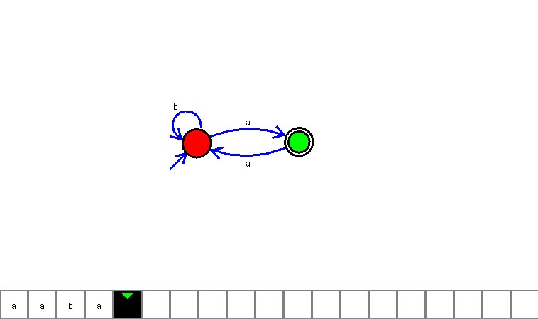

**Result**

The DFA is designed to compute the strings as input using Automaton Simulator